INTERNSHIP REPORT(IBM)

NAME:R.RAJA
ROLLNO: 23AD039
USE CASE: AUTHENTICATION SYSTEM CLASS:III-AI&DS

Summary:

This project is a Full-Stack Basketball Authentication System. The frontend is built with React.js.
The backend is powered by Node.js and Express.js.
The database is MongoDB, managed through Compass. Players can register via the signup page and their details are stored in the mongo database.
They can also log in, with credentials validated from the mongo database.
The system supports player registration.
Player details are stored securely in the database. The system includes a login feature.
Login validates user data from the database.
It is a complete React–Node–Express–MongoDB solution.

Work Flow:

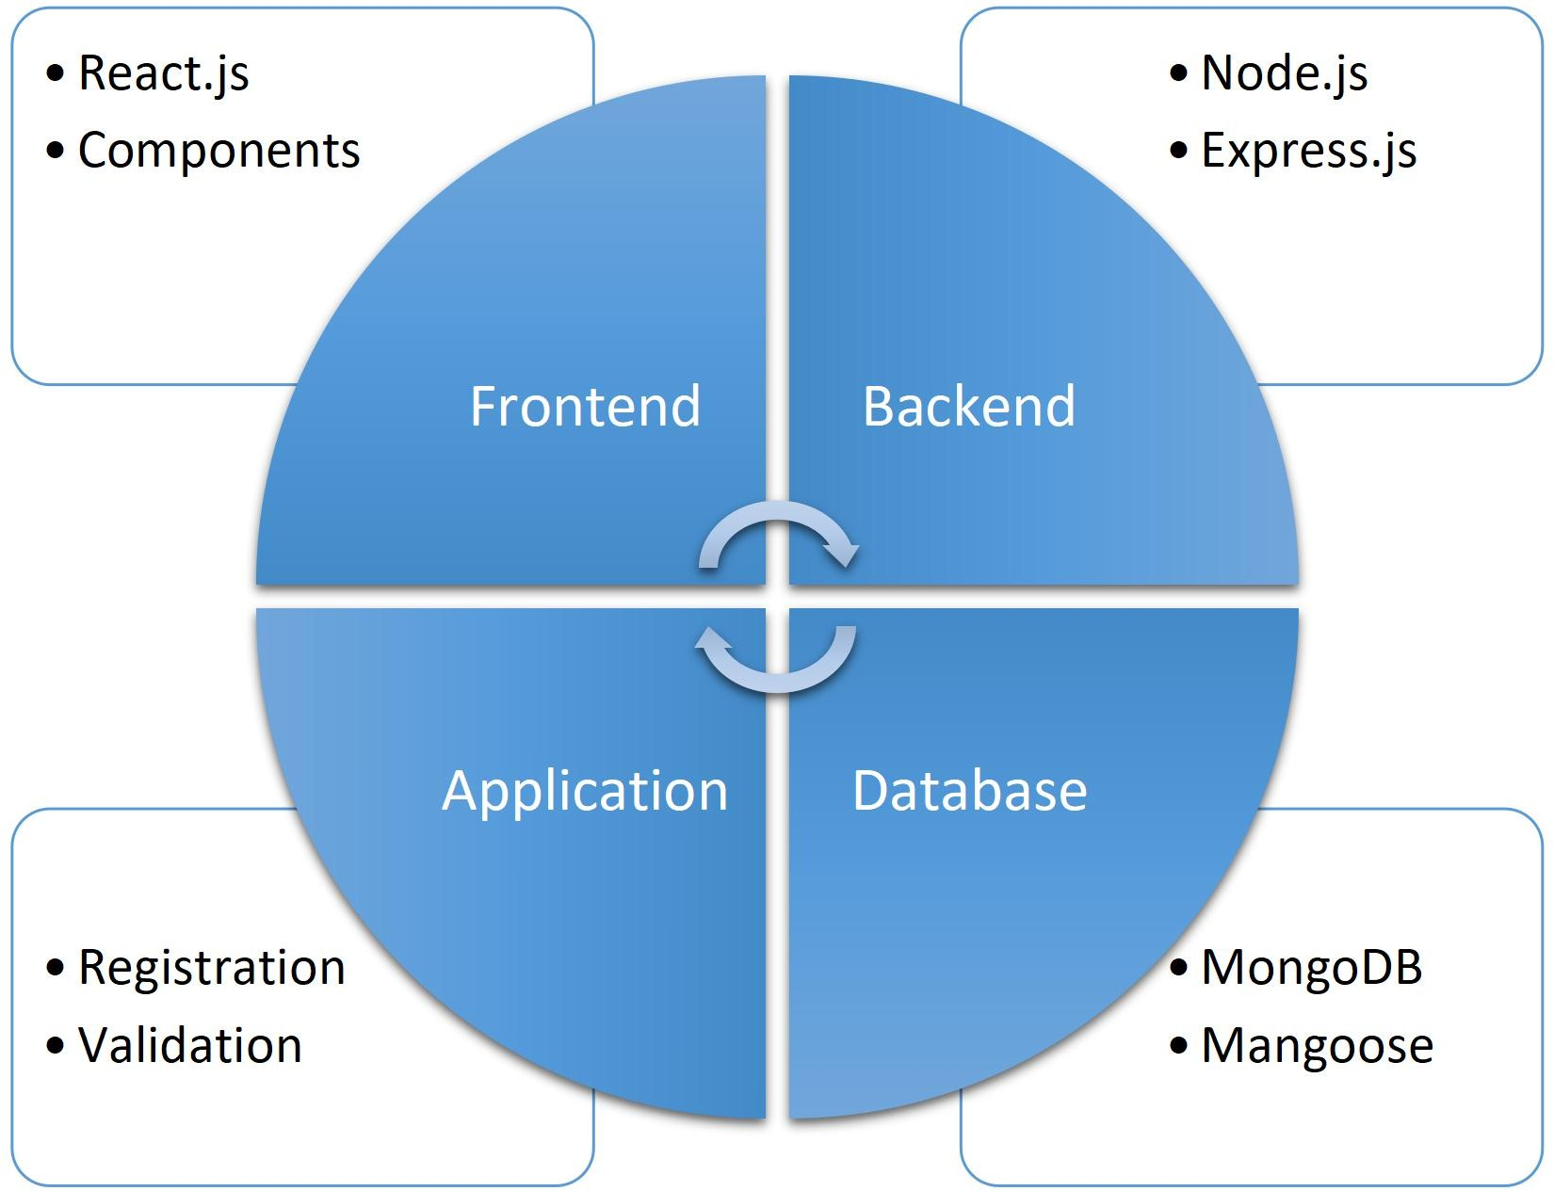

Work flow steps:

- React.js (Frontend )→ Where users interact (sign up / login).
- User Form → Players enter registration/login details.
- Express.js (Backend )→ Handles requests from frontend.
- MongoDB (Database) → Stores details in DB.
- Validation → Fetch data from DB to validate.

VS Code Structure

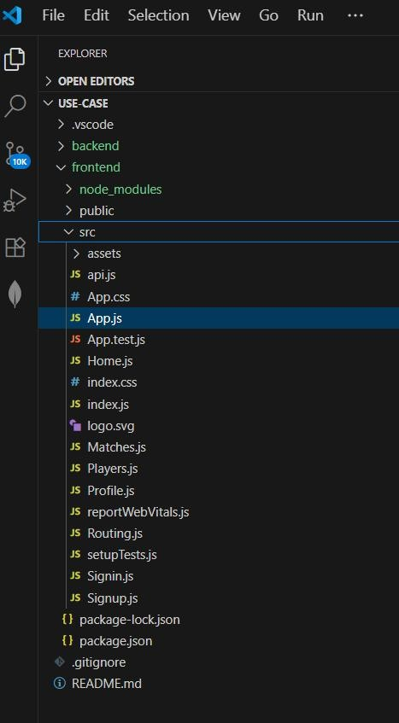

CODE :

App.js:
import React from "react"; import "./App.css";
import Routing from "./Routing";

function App() { return (
<div className="App">
<Routing />
</div>
);
}
export default App;

Api.js:
const API_URL = "http://localhost:5000/api";

// Signup API
export async function signupUser(userData) { const res = await fetch(`${API_URL}/signup`, {
method: "POST",
headers: { "Content-Type": "application/json" }, body: JSON.stringify(userData),
});
return res.json();
}
// Login API
export async function loginUser(loginData) { const res = await fetch(`${API_URL}/login`, {
method: "POST",
headers: { "Content-Type": "application/json" }, body: JSON.stringify(loginData),
});
return res.json();
}

Server.js
// 1 Import packages
const express = require("express"); const mongoose = require("mongoose"); const cors = require("cors"); require("dotenv").config(); // load .env

// 2 Create Express app const app = express();
// 3 Middleware
app.use(express.json()); // parse JSON from frontend app.use(cors()); // allow frontend requests
// 4 Connect to MongoDB mongoose.connect(process.env.MONGO_URI, {
useNewUrlParser: true, useUnifiedTopology: true
})
.then(() => console.log("MongoDB Connected"))
.catch(err => console.error("MongoDB connection error:", err));
// 5 Test route
app.get("/", (req, res) => { console.log("GET / called"); // debug log res.send("Backend API is running...");
});
// 6 User Schema including username/email const UserSchema = new mongoose.Schema({
name: String,
email: { type: String, unique: true }, password: String
});
const User = mongoose.model("User", UserSchema);
// 7 Signup API
app.post("/api/signup", async (req, res) => { console.log("POST /api/signup called"); console.log("Request body:", req.body); try {
const { name, email, password } = req.body; if (!name || !email || !password) {
return res.status(400).json({ message: "All fields are required!" });
}
const existingUser = await User.findOne({ email }); if (existingUser) {
return res.status(400).json({ message: "Email already registered!" });
}
const newUser = new User({ name, email, password }); await newUser.save();
console.log("User saved:", newUser);
res.status(201).json({ message: `Player ${name} registered successfully!` });
} catch (err) {
console.error("Error saving user:", err);
res.status(500).json({ message: "Error registering user", error: err });
}
});

OUTPUT

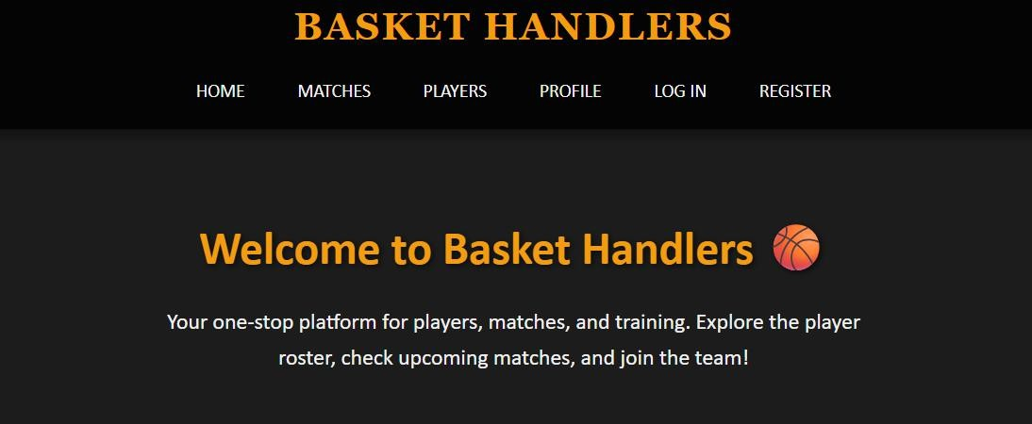
Authentication Webpage:

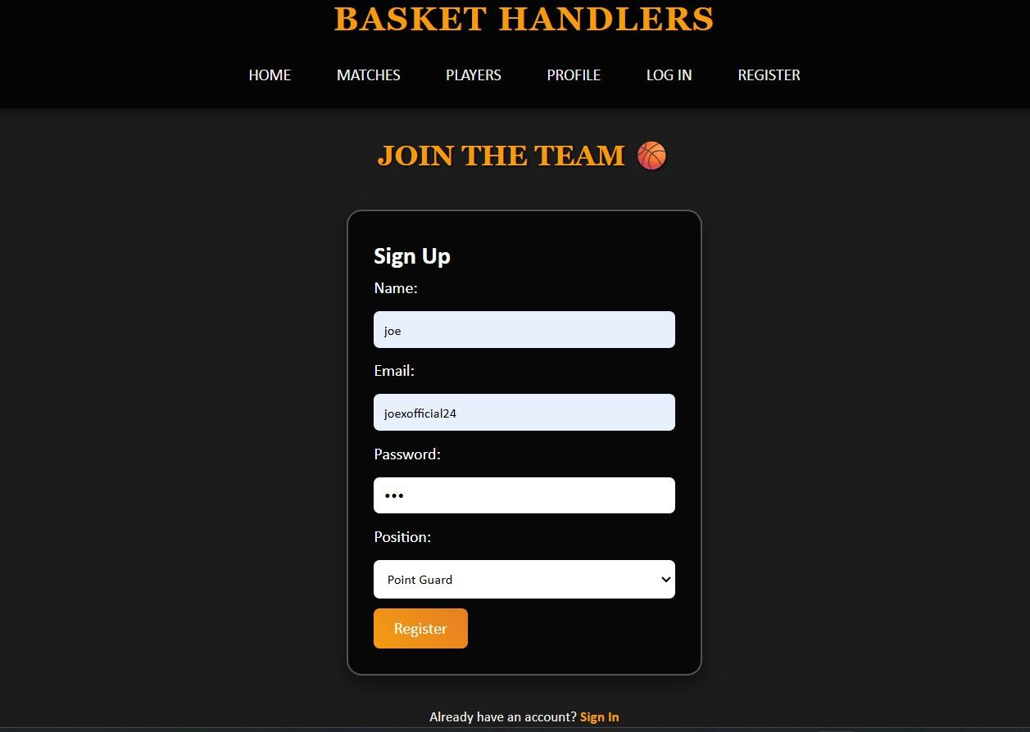

Database:

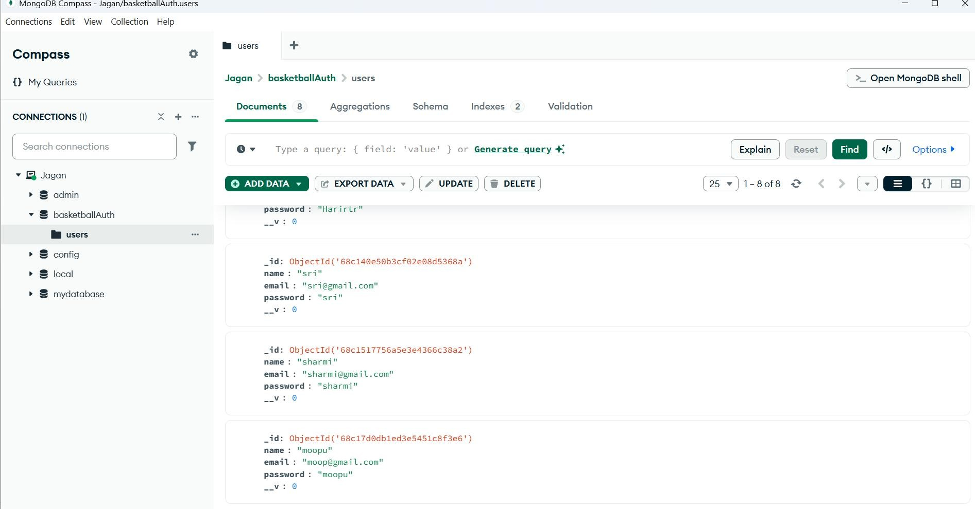

Conclusion:
This project successfully implements a Full-Stack Basketball Authentication System. It enables smooth player registration and login with data securely stored in MongoDB.
Overall, it demonstrates an integrated React–Node–Express– MongoDB solution for authentication.

